Olufisayo Joseph Ayodele

Database Systems

Project Report 2

MOVIES super class has 4 sub classes: ACTORS, NEWS & FEATURES, IN THEATRES, and DVD & STREAMING. It overlaps with the TV super class because ACTORS can be in a MOVIE and a TV show. ACTORS has a total participation because they have to be in one of the two or both. Hence, MOVIES and TV have a partial participation.

IN THEATRES and DVD & STREAMING are subclasses of MOVIES because a movie can either be IN THEATRES or in DVD & STREAMING. That’s why there is a disjoint constrain. MOVIES has a total participation because it has to be in one of the two, and IN THEATRES and DVD & STREAMING have partial participation because not every movie is IN THEATRES.

NEWS & FEATURES and TRAILERS have two super classes, that have total participation with them. Participation is total because every entity in the superclass is a member of the subclass in the specialization/generalization. That is every MOVIES and TV show have NEWS & FEATURES on them and TRAILERS also.

TV is the superclass of MOST POPULAR and CERTIFIED FRESH, and they overlap because a CERTIFIED FRESH show can also be part of MOST POPULAR. The superclass has a partial constraint because not every TV show is in either the MOST POPULAR or CERTIFIED FRESH category. MOST POPULAR and CERTIFIED FRESH both have total constraint because they are both in the TV.

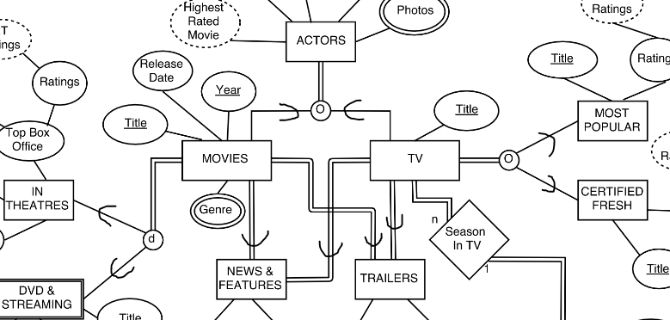

EPISODES and SEASONS are both similar super classes. They both have a disjoint, total relationship with their sub classes because all EPISODES have a DIRECTOR and WRITER, and all SEASONS have a NETWORK and PRODUCERS. Their subclasses relationship is partial because the subclasses can’t belong to any other subclass in the superclass. For example: a writer cannot be a director.

